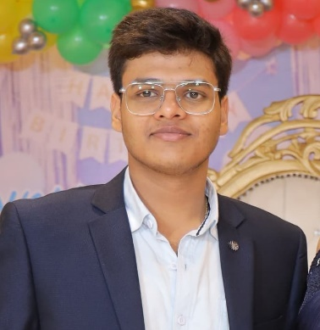

**HARSHIT JAIN**

**Email:** [**harshitjain2804@gmail.com**](mailto:harshitjain2804@gmail.com)

**Phone:** [+91-9319693911](tel:+919319693911)

**Address:** [Maujpur, Delhi-110053, INDIA](https://www.google.com/maps/place/Delhi/@28.6442873,76.763556,10z/data=!3m1!4b1!4m6!3m5!1s0x390cfd5b347eb62d:0x37205b715389640!8m2!3d28.7040592!4d77.1024902!16zL20vMDlmMDc?authuser=0&entry=ttu)

## Professional Summary

I am an Engineering Student currently pursuing B.Tech in Computer Science Engineering with a specialization in AI & ML.

## Work Experience

I am a fresher and have no work experience yet.

But I have worked on Some basic projects on my own.

## Education

**Arwachin Bharti Bhawan Sr Sec School**

Completed schooling

**K.I.E.T. Group of Institutions, Muradnagar**

Currently pursuing B.Tech in Computer Science Engineering with a specialization in AI & ML

## Skillsge Seeker

HTML

Enhancing Coding Skills

Knowledge Seeker

Hardworking

CSS

Python Language

C Language

## Projects

**Landing Page-** A basic landing page created locally.

**School Home Page-** A basic local trial home page of a school website.

And still working on more Projects to enhance my skills.

**Sign-Up and Login Page-** Basic sign-up and login page.